A NEW SINGLE-PHASE SWITCHED-COUPLED-INDUCTOR DC–AC INVERTER FOR PHOTOVOLTAIC SYSTEMS
ABSTRACT
This paper presents a new single-phase switchedcoupled-inductor dc–ac inverter featuring higher voltage gain than the existing single-phase qZ-source and semi-Z-source inverters. Similar to the single-phase qZ-source and semi-Z-source inverters, the proposed inverter also has common grounds between the dc input and ac output voltages, which is beneficial especially for photovoltaic inverter systems. The inverter volume and maximum current flowing can be reduced significantly through the coupling of all inductors. A theoretical analysis of the proposed inverter is described and a 280-W experimental prototype is built to verify the performance of the inverter.

BLOCK DIAGRAM FOR PROPOSED SYSTEM
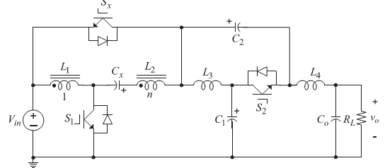
Fig. 1. Proposed dc–ac inverter.
DESIGNG SOFTWARE AND TOOLS:
MAT LAB /SIMULATION Software and simu power systems tools are used. Mainly control system tools, power electronics and electrical elements tools are used.

